Exercise 2-4 Feature Map Visualization (2 Classes)

Jirayu Petchhan, D10907801

**My selected pic (catndog.jpg)**

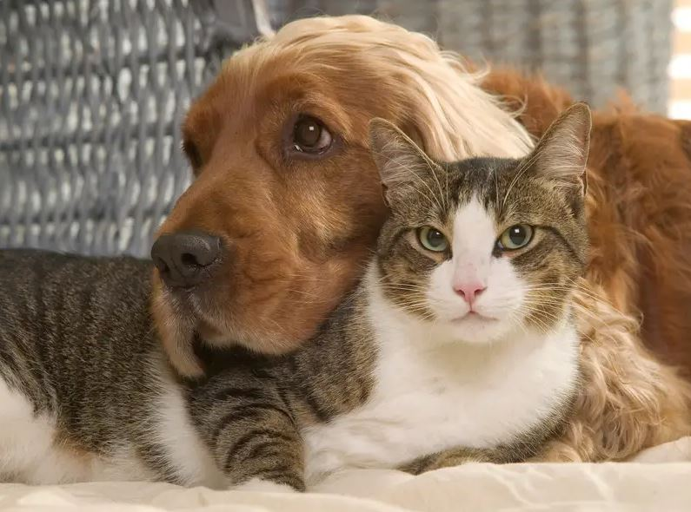

**Coding**

if __name__=='__main__':

# get class

c = {}

with open("imagenet1000_clsidx_to_labels.txt") as f:

for line in f:

(key, val) = line.split(":")

c[int(key)] = val.split(",")[0]

# Define image path and select the layer

myClass=FeatureVisualization('./catndog.jpg',5)

print(myClass.pretrained_model2)

myClass.save_feature_to_img()

myClass.predict()

**Code displaying**

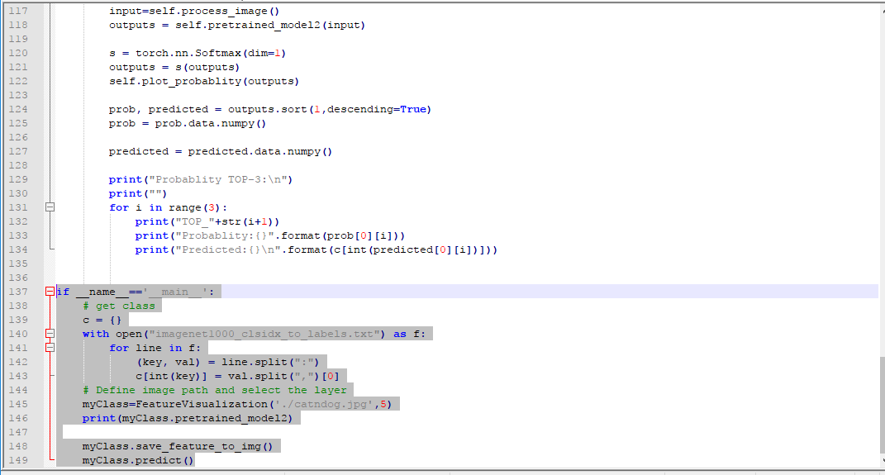

**Image Classifier after training**

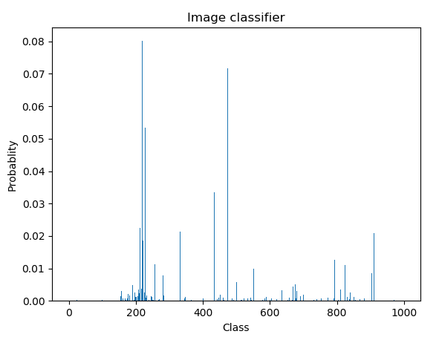

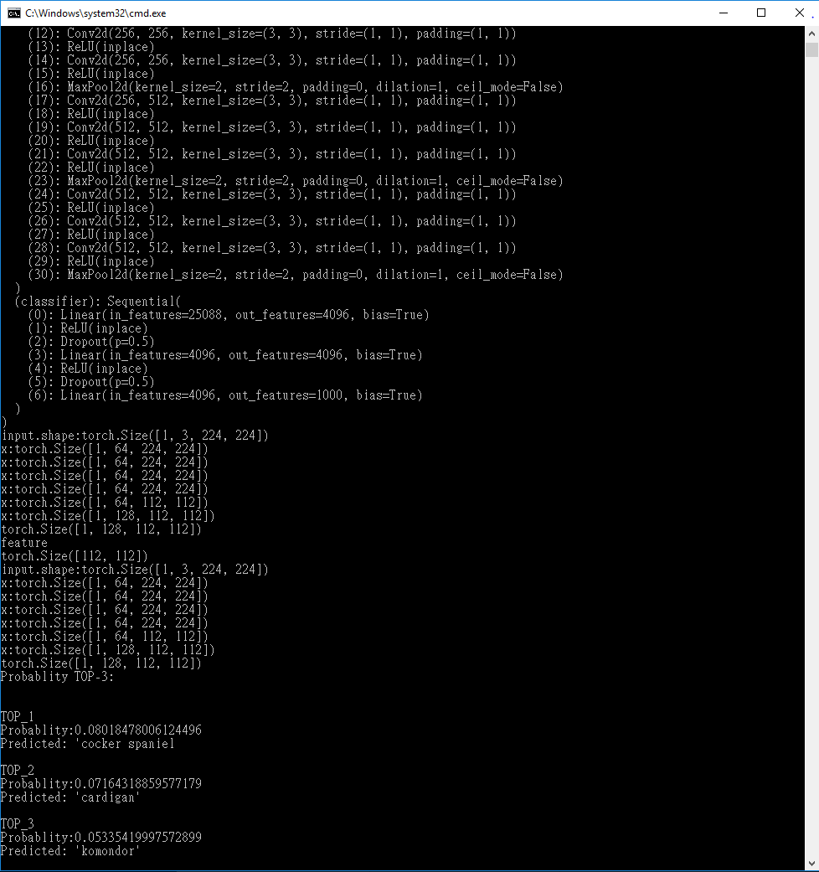**Result after training model**

Result was

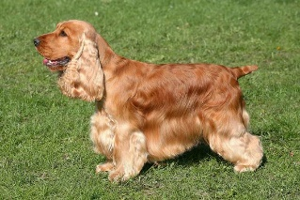Cocker spaniel 8.02 %

Cardigan 7.16 %

Komondor 5.34 %

Cocker Spaniel